# 

# **Department of Computer Science and Engineering Islamic University of Technology (IUT)** A subsidiary organ of OIC

# **Laboratory Report**

# CSE 4512: Computer Networks Lab

## 

## **Name: KHALID HASAN ADOR Student ID: 210042102 Section: B Semester: 4th Academic Year: 2023-2024**

**Date of Submission: 06/04/24**

### **Title:** Configuring ACL and NAT in Cisco Devices

### **Objective**:

1. Describe the concept of Access Control List (ACL)
2. Implement standard numbered ACL
3. Describe the concept of Network Address Translation (NAT)
4. Explain different types of NAT configuration
5. Implement NAT in a given topology

### 

### **Devices/ software Used**:

* + - 1. Cisco Packet Tracer

### **Diagram of the experiment(s):**

*(Provide screenshot of the final network topology. Make sure to label the network components.)*

**TASK 1:**

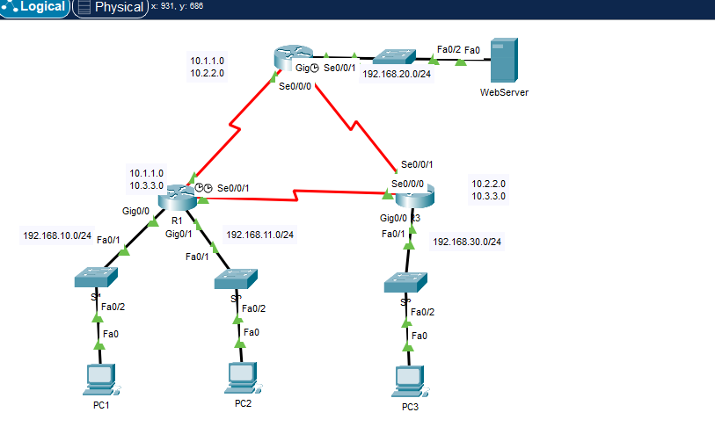

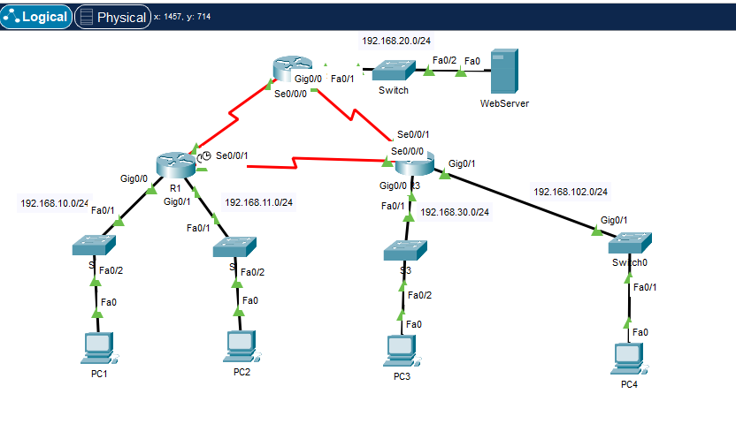

**TASK-2:**

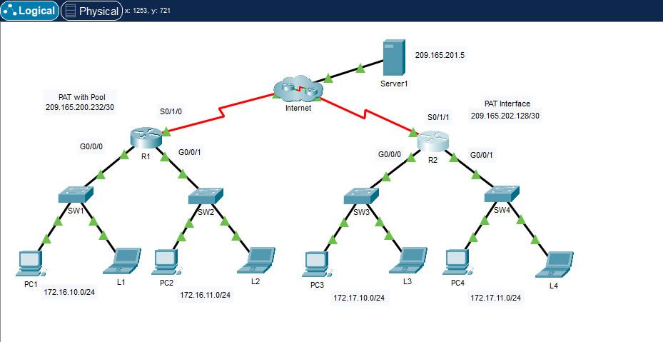

### **Working Procedure:**

***(****Explain in brief how you completed the tasks. Provide necessary screenshots of used commands for each task.)*

**TASK 1:**

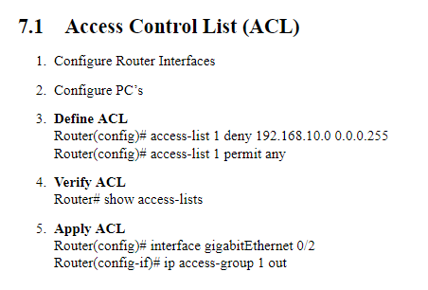

### **Questions**:

**Task # 01:**

The ping from 192.168.10.10 to 192.168.11.10 is successful or not? Explain.

**Ans:** Successful.

The 192.168.10.0/24 network is not allowed to communicate with the 192.168.30.0/24 network. But it can communicate with 192.168.11.0/24 network.

The ping from 192.168.10.10 to 192.168.20.254 is successful or not? Explain.

**Ans:** Successful.

The 192.168.10.0/24 network is not allowed to communicate with the 192.168.30.0/24 network. But it can communicate with 192.168.20.0/24 network.

192.168.11.0/24 was restricted to communicate with 192.168.20.0/24 network.

The ping from 192.168.11.10 to 192.168.20.254 failed or not? Explain.

**Ans: Failed**

The 192.168.11.0/24 network is not allowed to communicate with 192.168.20.0/24 network.

**Task # 02:**

1. From the web browser of each of the PCs that use R1 as their gateway (PC1, L1, PC2, and L2), access the web page for Server1.

**Question:**

Were all connections successful?

ANS: YES

1. From the web browser of each of the PCs that use R2 as their gateway (PC3, L3, PC4, and L4), access the web page for Server1.

**Question:**

Were all connections successful?

ANS: ANS

1. Compare the NAT statistics on the two devices.

**Question:**

Why doesn’t R2 list any dynamic mappings?

### **ANS:**

PAT establishes many-to-one mapping between multiple local hosts and a single global IP address. It uses the Port (TCP/UDP port) information to distinguish between different internal hosts and assign a single global IP to all those addresses thus greatly conserving the global address pool. We implemented PAT on R2 so R2 doesn’t list any dynamic mappings.

### **Observation**:

### **Challenges (if any):**

**References:**

1. <https://www.overleaf.com/read/hgvcxznjzyhn#1eb6a4> (Some working procedure SS was taken from this personal notebook)